Novices go to Hilfield

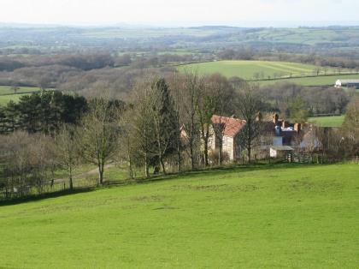
At the beginning of May, Fabian NovCR and I attended the third in a rolling programme of internovitiate study courses. These are principally intended to allow novices from our diverse Anglican communities across the country to meet together in a congenial atmosphere, chew the fat of the common life over somewhat and engage our minds and hearts over a specific topic or area of study.
Following a successful get-together at HR in February, it was once more time for us to convene in the delightful venue that is Hilfield Friary in Dorset, home to the Society of St. Francis and situated in beautiful countryside, with green fields as far as the eye could see. We were there to think specifically about ‘Care for our Common Home’ viz. The topic of Pope Francis’s latest encyclical letter. It was certainly a most conducive space in which to do so. The friary has long had a reputation for its advanced thinking on ecological matters and their especial relationship to theology and discipleship.
So it was that Br. Sam SSF who is keenly immersed in the subject helped to get us pondering and discussing all this. We heard different community takes on environmental issues, with each community represented airing frustrations and sadnesses with regard to the degredation of our ecosystems, whilst acknowledging our unique Christian perspective of hopefulness within a bleak situation. It was a good forum in which to consider what we might begin to do as religious against the backdrop of what is becoming an evermore catastrophic state of affairs, and also to take heart for the things which we already offer as those seeking to live after the pattern of Jesus’ first disciples.
The Society of St. Francis teaches that eco-theology is very much about the ‘household’ attitude to our care for the environment in which we are set. To that end, they have invested in electric cars, eat a mainly vegetarian diet, sourcing only meat bred and killed on-site and exercise a careful attitude to the farming of land that is dictated by that land’s seasonal rhythms. It was beautiful to walk in one of the foremost sites in the whole county for wild flowers (chiefly orchid species) and to be ably introduced to the various types of edible plant life from trees around the friary. Richard, the site manager and an excellent botanist led us on a great tour highlighting such things. My personal favourite part of the tour was being shown how oak trees are parasitized. It was hugely insightful for us all and a real inspiration of God’s divinity at work in His creation.
As well as all of this, there was the natural opportunity to take part in a couple of socials, sample the home-brew and talk together in a lighter way during a couple of the evenings before travelling back on Friday afternoon. I am coming to really appreciate the ‘iternovs,’ as they seem to strike a good balance between learning and recreation: two key ideas at the heart of Christian discipleship. This last is also beginning to feed into some of our own ‘green’ thinking here at CR. Time, therefore, well spent indeed for the novitiate. September will hopefully see a trip to Oxford and an exploration together on ‘The History of Anglicanism.’ I hope to provide an account for CRQ in due course.
Marc, Novice CR

